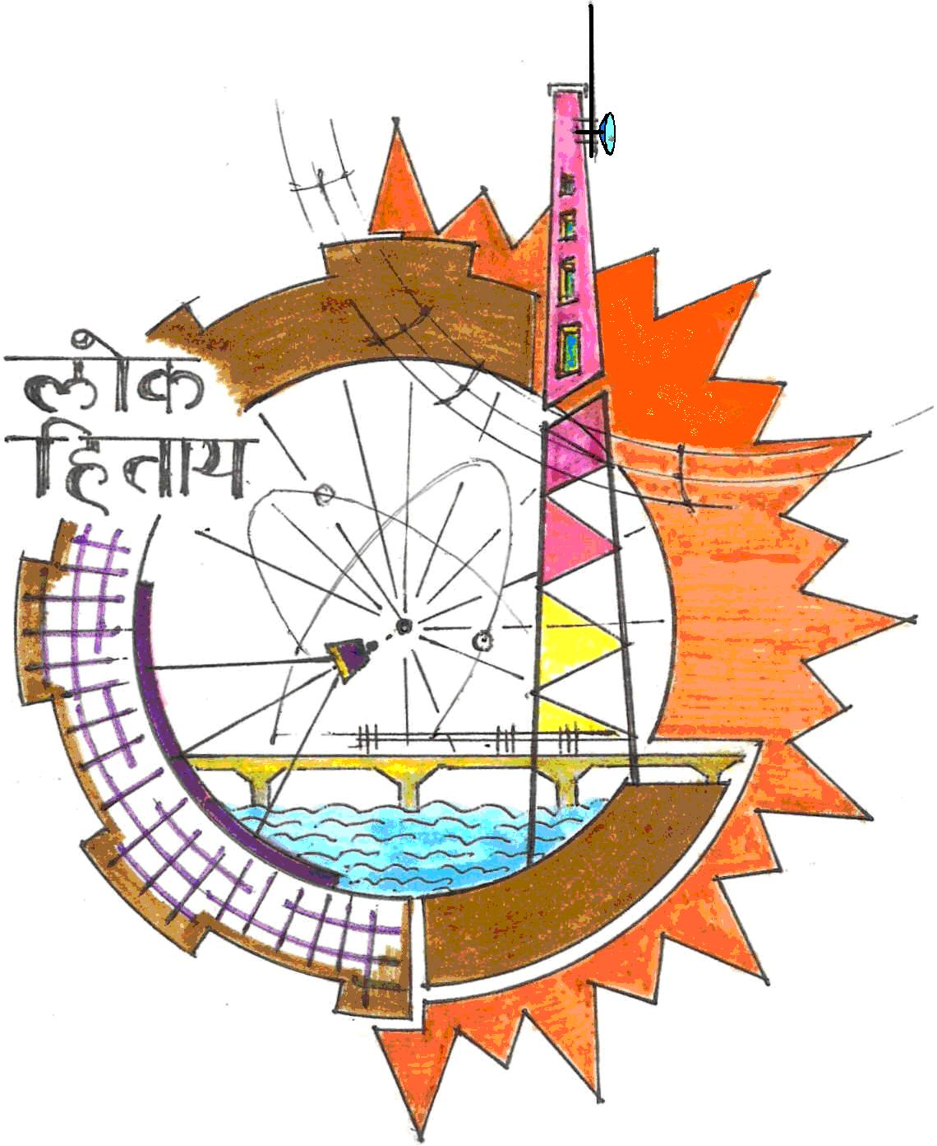

OFFICE OF THE PRINCIPAL
GOVERNMENT ENGINEERING COLLEGE
OLD DHAMTARI ROAD, SEJBAHAR, RAIPUR (C.G.)
PHONE NO. 0771-2102860, 2103147 website: www.gecraipur.ac.in, E-mail–principal@gecraipur.ac.in

PART TIME FACULTY RECRUITMENT APPLICATION FORM

1. Name of Candidate: ……………………………………………………..

Photograph
2. Father’s name: …………………………………………............................
3. E-mail: …………………………………………………………………...
4. Mobile No.: ……………………………………………………………...
5. Correspondence Address:

…………………………………………………………..……………………………………....………
………………………………………………………………………………………..………..….……
……………………………………………………………………………………………...…..….……
6. Permanent Address:
……………………………………………………………………………………………..….…..……
…………………………………………………………………………………..…………….…..……
…………………………………………………………………………………..…………….…..……
7. Educational Qualification:
S.No. | Qualification/  Degree | University | Subject/Topic | Year | Percentage
1 | BE/B. Tech
2 | ME/M. Tech.
3 | Ph.D.

8. Publication:
8(A) Details of Patents:
S.No. | Title of Patents | Name of Inventors | Awarding  Organization | Date of Award | Registration Number
1
2
3
4

8(B) Details of Book/Book Chapters:

S.No. | Title | Authors | Year | Name of Publisher | ISBN
1
2
3
4
5

8(C) Details of Research Papers (Journals):

S.No. | Type | Publication Date | Title | Details of Journal
1
2
3
4
5

8(D) Details of Research Papers (Conferences):
S.No. | Type | Publication Date | Title | Details of Conference
1
2
3
4
5

9. Teaching Experiences:
S.No. | Name of Employer | Duration  (From – To) | No. of Months
1
2
3
4
5

Signature of candidate

Note: Submit your application form along with self-assessment form and Self Attested relevant documents

Self Assessment Form

Marks assigned | Marks Distribution | Marks Claimed by the Applicant
Under – Graduate (B.E./B.Tech.)  30% of net percentage obtained* | 30
Post-Graduation (M.E./M.Tech./MS)  30% of net percentage obtained* | 30
Ph.D. Degree | 10
Patent Published Holder | 2.5 Marks per Patent  Max. 05 Marks
Books published Book Chapter:  Authored book having ISBN number | 01 Marks for Books Chapter  02 Marks for Books  Max. 05 Marks
Research publication details SCI/Scopus indexed paper/UGC care/ISSN number papers | Journal: 02 Marks per Paper  Conference: 01 Mark per paper  Max. 10 Marks
Previous employment experiences  (Engineering UG/PG Only) | 01 Marks for 06 Months  Max. 10 Marks
TOTAL MARKS FOR MERIT | 100 Marks

*Equivalent percentage for CGPA system to be calculated.

Signature of candidate

